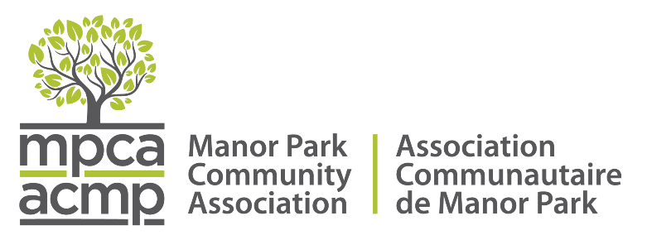
MANOR PARK COMMUNITY ASSOCIATION
MINUTES OF MEETING: November 25, 2025, 7:00 P.M.
VIA ZOOM

Present: Natalie Belovic (President), Sean Shuk (Development and Zoning), Louise Jones (Secretary), Elizabeth McAlister, Patrick Hill (Transportation)
Regrets: Diana Poitras (Treasurer, Community Outreach), Councillor Rawlson King
Natalie: The meeting began with introductions and attendance updates
Rawlson King: Unable to attend the meeting, sent the following notes:
- The Vanier BIA intends to host a special community meeting for residents across our five neighbourhoods. Due to a busy schedule (they just opened their new and improved HUB yesterday), they are hoping to organize this opportunity in the New Year. Our office will be in touch once these details are finalized.
- As well, Councillor King is inviting Manor Park residents to join him, along with City staff from Recreation, Cultural and Facility Services, as well as from the Parks Planning team, to a ribbon cutting event to celebrate the reopening of Hemlock Park. There will be brief remarks, a ribbon cutting, hot chocolate and treats. The event takes place Wednesday, Dec. 3 from 3:30 to 4:15 pm. The timing of the event coincides with the afternoon bell time at Manor Park Public School so that families have an opportunity to drop by for this occasion.
Natalie called the meeting to order.
- The meeting began with introductions, welcoming Patrick as a new board member. His membership will be confirmed at the AGM. Patrick shared his background, expressing his desire to contribute to the neighbourhood.
- Natalie led the meeting, discussing agenda approval and minute reviews, with Louise confirming the distribution of minutes for April, September, and October.
- Louise brought up a motion to approve the draft agenda, seconded by Patrick and passed.
- Louise will resend minutes from April, September and October and make any changes to approve online.
Crossings update: Natalie: a coalition letter was sent to local media (le Droit and the Ottawa Citizen) criticizing the NCC's consultation process and lack of supporting data for the proposed crossing.
- A letter has been drafted and has received the support of other community associations (Lindenlea, Carson Groves). Once New Edinburgh confirms, the letter will be sent to municipal, federal provincial representatives to raise our concerns. Next meeting December 11, for consultation process at noon at St Laurent complex, Natalie will attend.
Other concerns: Natalie:
- Budget session: about 24 people logged in, lack of interest from Ward 13. There was a presentation by staff of a slide deck, were a few questions.
- Incorporation, currently the MPCA is incorporated under the province of Ontario as a non-profit. The group discussed their current provincial incorporation status and the previous attempt to switch to federal incorporation, with Natalie planning to follow up with Asma about the reasons for not completing the federal incorporation.
- The board discussed the installation of sidewalks in Manor Park, with Natalie expressing concerns about the city's policy of building sidewalks in some new subdivisions but not others. Louise noted that not all board members were opposed to sidewalks, and Patrick suggested finding a compromise that would advance the city's objectives while addressing neighborhood concerns. Elizabeth shared perspectives from disabled residents who moved to Manor Park for its accessibility, highlighting the need to consider various viewpoints. The group discussed the timeline for sidewalk construction, with work likely to resume in the spring, and the potential impact on snow removal and parking. Natalie explained she would respond to Mark Patrie by acknowledging the board's divided stance and advocating for sidewalks only where genuinely needed, while avoiding a formal declaration. The board members debated the reliability of various surveys conducted by different individuals, noting that not all residents were surveyed. The group agreed to maintain a neutral position for now, though Natalie indicated she would speak at the upcoming city hearing.
Community outreach – Natalie:
- The board discussed several community matters, including a $200 allocation for gift cards to be distributed at two upcoming Christmas parties hosted by Rideau-Rockcliffe Community Association at Yule Coop and 500 St. Laurent. Mary and Elizabeth attended a meeting with Jennifer at Rideau Rockcliffe and tenants of Yule Coop how to decide how to distribute the grant, deciding it will go to food, as up to 50% of residents experience food shortages. Other community housing locations are setting up pantries run by community members. Looking to see how the pantries work in new buildings before establishing one at Yule.
- On December 3, police will provide an update on 3 local murders (Apple tree, bus station, and Meadow Park Place (probably aviation parkway)) for Manor Park Hill and 500 St. Laurent residents. Sean will attend the meeting.

Zoning – Elizabeth:
- Elizabeth and Sean have reviewed the third draft of the zoning bylaw, which Elizabeth noted differs substantially from the Official Plan and has faced significant pushback.
- She has drafted a response to send to Rawlson’s office, Sean will add section on Birch, Hemlock and overlay sections and also issues behind the strip mall.

Next meeting December 16th

